Custom CAM operation steps
- Add pictures
Picture folder path: install \CAM
Image properties:
Resolution: 360 * 180
Bit depth: 24bit
Picture Format: BMP
The image file name corresponds to:
menu | Image file name
CAM1 | cam10.bmp
CAM2 | cam11.bmp
CAM3 | cam12.bmp
CAM4 | cam13.bmp
CAM5 | cam14.bmp
CAM6 | cam15.bmp
CAM7 | cam16.bmp
CAM8 | cam17.bmp
CAM9 | cam18.bmp
CAM10 | cam19.bmp

Example：

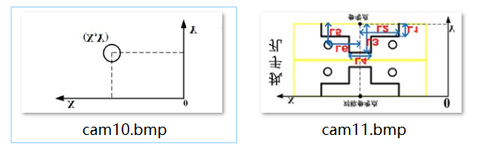

- Add parameters
Chinese Parameter Folder Path: Install\chs
English Parameter Folder Path: Install\eng
Parameter number range 1100-1499;
Macro address: # 2600- # 2999

Parameter index corresponding table:
menu | Parameter index
CAM1 | m30
CAM2 | m31
CAM3 | m32
CAM4 | m33
CAM5 | m34
CAM6 | m35
CAM7 | m36
CAM8 | m37
CAM9 | m38
CAM10 | m39

Example：
#1100 -p0 -a3 -t0 -s1"Parameter name 1" -s2" " -m30 -min=-9999.999 -max=99999.999
-s3"Description of parameter 1."
#1101 -p0 -a3 -t0 -s1"Parameter name 2" -s2" " -m30 -min=-9999.999 -max=99999.999
-s3"Description of parameter 2."
#1102 -p0 -a3 -t0 -s1"Parameter name 3" -s2" " -m30 -min=-9999.999 -max=99999.999
-s3"Description of parameter 3."

#1103 -p0 -a3 -t0 -s1"Parameter name 1" -s2" " -m31 -min=-9999.999 -max=99999.999
-s3"Description of parameter 1."
#1104 -p0 -a3 -t0 -s1"Parameter name 2" -s2" " -m31 -min=-9999.999 -max=99999.999
-s3"Description of parameter 1."
#1105 -p0 -a3 -t0 -s1"Parameter name 3" -s2" " -m31 -min=-9999.999 -max=99999.999
-s3"Description of parameter 3."

- Add corresponding processing code
File storage path: / local
Processing code correspondence:
menu | Processing file corresponding table
CAM1 | cam10.nc
CAM2 | cam11.nc
CAM3 | cam12.nc
CAM4 | cam13.nc
CAM5 | cam14.nc
CAM6 | cam15.nc
CAM7 | cam16.nc
CAM8 | cam17.nc
CAM9 | cam18.nc
CAM10 | cam19.nc

Example：
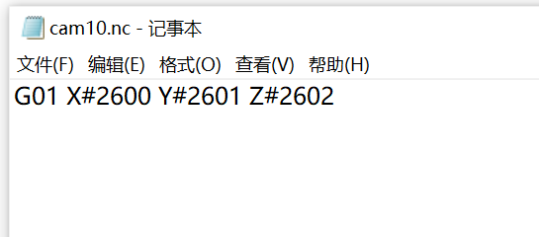

- Function Key Subject Number

Corresponding shortcut key ratios: 1399

- Operation
- The 210 parameter is set to 1399;
- Copy the corresponding parameters and processing files to the corresponding file directory,
- Press K1 button
- Select the corresponding CAM;
- Set parameters;
- Press the start button to process;

